**Title**

Kristina V. Akulinina, Alexander V. Kirdyanov, Vladimir V. Kukarskih, Alexey I. Kolmogorov, Viktora V. Agapova, Alberto Arzac

**Abstract**

An increase in temperature in high latitudes will lead to changes in the water balance and thermal regime of permafrost soils, which will affect the structure and functioning of plant communities in northern biogeocenoses. A method for studying the response of plant communities to environmental and climate changes is dendroclimatic analysis of the radial growth of trees. The article presents the results of such an analysis for the trees *Pinus sylvestris, Larix sibirica, Larix gmelinii and Larix cajanderi*, growing in a zone of continuous permafrost in six areas within the Arctic Circle.

A correlation analysis was carried out between tree ring width indices and climate indicators for the period from 1966 to 2021. The results showed that the main factor limiting the radial growth of trees in all study areas is air temperature, mainly in June and July. Sliding correlations showed that in recent decades there has been an increase in the influence of temperature anomalies on tree growth, especially under conditions of increasing average daily temperature. This indicates potential changes in the structure of plant communities and their adaptation to new climatic conditions. It was also noted that an increase in temperature in the summer months leads to a more pronounced positive dynamics of radial growth, which may be associated with improved photosynthetic processes and increased water availability under conditions of permafrost thawing. In conclusion, the results emphasize the importance of further research aimed at assessing long-term changes in northern ecosystems in response to global warming.

**Keywors:** Arctic, climate change, tree growth, tundra,treeline

1. **Introduction**

In the last decade, an unusual phenomenon has been observed in the Arctic region: unprecedented warming in the forest-tundra ecotone. This climate change has a significant impact on the dynamics of biogeocenoses in this region. However, the effects of warming are not limited to changes in plant communities. They also affect deep soil processes, influencing the timing of the formation of the active soil layer in areas of continuous permafrost.

In addition to negative effects, rising temperatures can also create favorable conditions for tree growth. Higher temperatures and earlier access to water due to thawing permafrost can contribute to the flourishing of vegetation in the region. Research (Vaganov E.A., Hughes M.K., Kirdyanov A.V., Schweingruber F.H., Silkin P.P., 1999) confirms that all these factors are already affecting the condition of forests and their components. Such changes can have consequences not only for biodiversity, but also for ecosystems in general.

The width of tree rings is directly related to growth conditions, which depend on temperature, precipitation, and other environmental factors. The aim of the work is to assess the climate response of tree radial growth to changes in temperature, precipitation, active soil depth, snow depth, and wood species.

Studying these changes and their possible consequences is becoming increasingly important in the context of global climate change and anthropogenic activities. In addition, changes in forest-tundra ecosystems can serve as indicators of broader climate trends, making their study key to assessing future change scenarios in Arctic regions.

**2.1 Study area and sampling**

The research was carried out at six localities in a longitudinal transect above the Arctic Circle, from northeastern Finland to northeastern Russia (27°E to 166°E; Fig. 1A). Four main conifer species in the forest-tundra ecotone were sampled (i.e., *Pinus sylvestris*, *Larix sibirica*, *Larix* *gmelinii* and *Larix cajanderi*). Thus, in the westernmost sites, Finland (hereafter FIN) and Apatity in the Kola Peninsula (hereafter APA) - *P. sylvestris*. In the central sites, the Polar Urals (hereafter PUR) - *L. sibirica* and Khatanga (hereafter KHA) - *L.gmelinii*. In the easternmost sites Chokurdakh (hereafter CHO) and Bilibino (hereafter BIL) *L. cajanderi*. The sites are characterized by harsh climatic conditions that significantly affect the growth and development of tree species. Temperature fluctuations, short growing seasons and low precipitation levels create specific conditions. Thus, over the 1966-2021 period, mean annual air temperature ranges from 0,3 °C in APA to -13,1°C in CHO (Fig. 1B), and the annual precipitation totals from 558 mm in the APA to 210 mm in BIL (Fig. 1B). Climate data from the nearest weather station to the sampling sites were obtained from climexp.knmi.nl (Finnish site) and www.meteo.ru (Russian sites).

The average annual temperature trend for each site shows a general increasing trend (Fig. 1C), as do the temperatures of the combined months (June–September) (Fig. 1D). Average number of days per year with temperatures equal to or above 5 °C for the study period 1966–2021 was 133 days and 70 days for the APA and CHO sections, respectively (Table 1). In addition, there is an increase in the number of days with temperatures equal to or above 5 °C at a variable rate from 44 to 52 days per decade at P < 0.01 for the more western and central sites, and 29 days per decade for Chokurdakh and 11 days for Bilibino (P < 0.01) (Supplement, Fig. 1A).

At each site, a minimum of 20 trees were sampled at breast height (1.3 m) with a 5-mm increment borer powered by an electric drill. Tree height and diameter at breast height (dbh) were recorded for the sampled trees (Table 1).

A 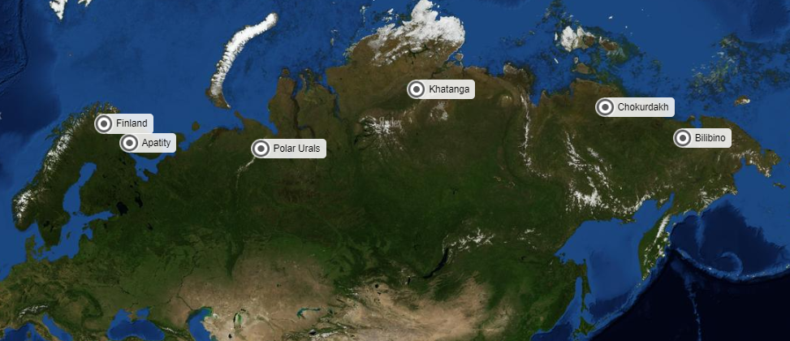

B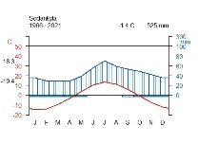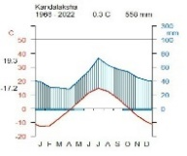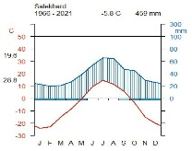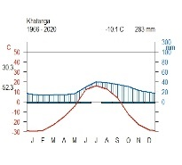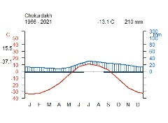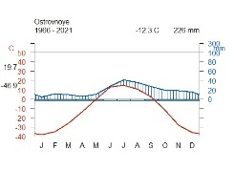

C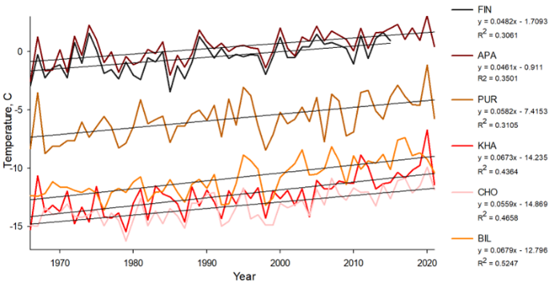 D 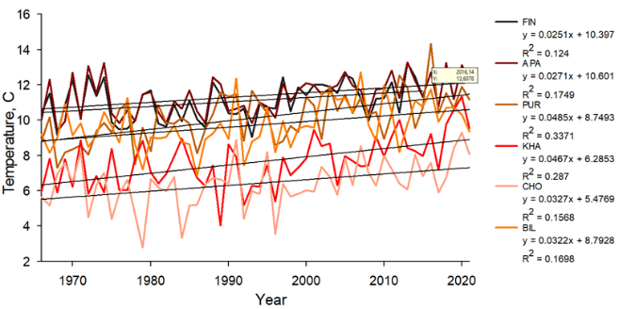

**Figure 1.** Location and climate of the study area: (A) white dots show the location of sampling sites (FIN, Finland, APA, Apatity; PUR, Polar Ural; KHA, Khatanga; CHO, Chokurdakh; BIL, Bilibino). (B) Climate diagram for Sodankyla weather stations, Kandalaksha, Salekhard, Khatanga, Chokurdakh, Ostrovnoye for 1966 – 2021 period. (C) Average annual temperature trends for the periods 1966–2021 in the study areas. (D) Trends in average monthly temperature June-September for the period 1966–2021 in the study areas.

**Table 1** - Characteristics of areas

|  |  |  |  |  |  |  |
| --- | --- | --- | --- | --- | --- | --- |
|  | FIN | APA | PUR | KHA | CHO | BIL |
| Coordinates | 68°77′ N  27°15' E | 67°36' N  33°2' E | 66°54' N  65°45' E | 71°57' N  102°40'E | 70°30' N  147°10' E | 68°02′ N  166°40' E |
| Elevation (masl) | 179 | 127 | 125 | 35 | 7 | 468Начало формы |
| Near weatherstation | Sodankyla  (52 km) | Kandalaksha  (62 km) | Salekhard  (58 km) | Khatanga  (7 km) | Chokurdakh  (2 km) | Ostrovnoye  (48 km) |
| T mean | -0.48 | 0.40 | -5.76 | -12.32 | -13.28 | -10.86 |
| T June-July | 13.09 | 13.05 | 11.90 | 9.43 | 8.31 | 13.05 |
| T June-September | 11.04 | 11.37 | 10.13 | 7.62 | 6.41 | 9.71 |
| P total | 526.56 | 547.48 | 457.21 | 283.10 | 210.40 | 237.10 |
| P June-July | 124.86 | 124.42 | 118.98 | 68.60 | 52.30 | 69.10 |
| P June-September | 235.50 | 242.80 | 229.53 | 141.14 | 104.36 | 131.05 |
| Days  ≥ 5 °C | 121+12,2 | 133+12,2 | 105+13,6 | 82+13,1 | 70+12,7 | 93+11,4 |

**2.2 RW measurements and chronologies construction**

The collected cores were subjected to resin extraction using a Soxhlet apparatus with 96% ethanol for 72 hours. After this, wood cores were fixed on wooden supports and polished with a grinding machine with a grit up to 1000. An Epson Perfection V800 flatbed scanner (Epson, Japan) was used to scan the polished cores. Tree-ring width (RW) was measured using CooRecoder version 9.3 (Cybis Elektronik & Data AB in Sweden). The wood cores were visually cross-dated and its accuracy was statistically checked with COFECHA (Grissino-Mayer 2001). In the ARSTAN program (Cook E.R., Holmes R.1996), standardization (indexing) of the original time series was performed using a negative exponential or linear function to compensate for age-related changes in ring width. Next, a procedure was carried out to remove the autocorrelation component in order to reduce the influence of non-climatic factors and preserve the high-frequency climate response (Cook E.R., Peters K.,1981). To assess the quality of the obtained chronologies, the following statistical parameters were calculated: sensitivity coefficient (msx), inter-series correlation coefficient (Rbar) and expressed population signal (EPS) (Table 2) (Wigley T.M.L., Briffa K.R., Jones P.D. 1984).

Table 2 - Сhronology characteristics for the period 1966–2021

|  |  |  |  |  |  |  |
| --- | --- | --- | --- | --- | --- | --- |
|  | **FIN** | **APA** | **PUR** | **KHA** | **CHO** | **BIL** |
| msx | 0.25 | 0.25 | 0.40 | 0.55 | 0.44 | 0.44 |
| EPS | 0.65 | 0.89 | 0.96 | 0.96 | 0.97 | 0.96 |
| Rbar | 0.48 | 0.40 | 0.63 | 0.68 | 0.64 | 0.69 |

**3. Results**

**3.1 Climate-growth analysis**

To assess the relationship between tree radial growth and climate conditions, pairwise correlation analysis was performed using Pearson correlation coefficients. The analysis was performed between standard chronologies and average monthly climate data, including total precipitation and average air temperature.

Tree-ring width showed a positive correlation with summer temperatures (June and July), but the timing and intensity of the climate signal varied between sites. Trees at sites PUR, KHA and BIL showed an earlier response to June temperature (r = 0.54; r = 0.43; r = 0.41, respectively, at P < 0.01), site CH r = 0.24 at P < 0.05, except for the westernmost sites (FIN and APA), where a significant relationship was found only for July temperature (r = 0.35 and 0.41, respectively, at P < 0.01) (Fig. 2A). Temperatures of the previous months, as well as March, had a significant negative effect on the radial growth of trees in the Chokurdakh area (Fig. 2A).

Correlation analysis between residual chronologies and monthly precipitation showed that precipitation affected radial growth only at the local level, without a clear pattern for all the study areas. Summer precipitation did not demonstrate a statistically significant effect on radial growth in the considered areas. The most noticeable positive effect of precipitation was found for the APA area in August (r = -0.39, p < 0.01) and in December of the previous year (r = -0.35, p < 0.01) (Fig. 2B). For the easternmost area (BIL), last year's October precipitation had a positive effect (r = -0.41, p < 0.01) and April precipitation had a negative effect (r = -0.37, p < 0.01) (Fig. 2B). In general, no long-term impact of precipitation on the radial growth of trees was detected in any of the study areas.

А 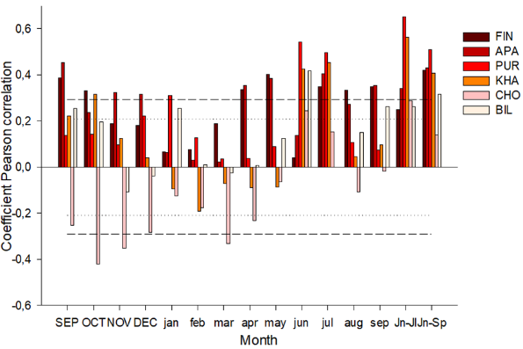B 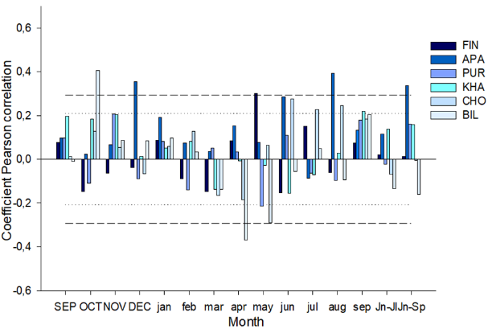

**Figure 2.** Coefficients of paired (A and B) correlations of tree-ring width with temperature and precipitation

Sliding correlations calculated on the basis of average daily data showed a positive influence of midsummer temperatures (June 23 – July 10) in all study areas (Fig. 3A). However, when moving from west to east along the northern profile, an increase in the maximum correlation coefficients is noted, as well as their shift to earlier dates. The seasonal dynamics of the influence of temperatures demonstrates a decrease in the significance of July temperatures and an increase in the influence of June temperatures on the variability of tree growth indices. In the western regions (FIN, APA), where Scots pine grows, the effect of July temperatures is weaker (DOY 191 and 190; r = 0.43 and 0.41; p < 0.01) compared to other locations where larch grows: the central sites (PUR, KHA), where the correlation coefficients reach a maximum (DOY 174 and 181; r = 0.65 and 0.67; p < 0.01), and the eastern sites of CHO and BIL (DOY 183 and 176; r = 0.56 and 0.54, respectively; p < 0.01). Analysis of the effect of precipitation did not reveal a significant long-term effect on the radial growth of trees at any of the study sites (Fig. 3A).

A 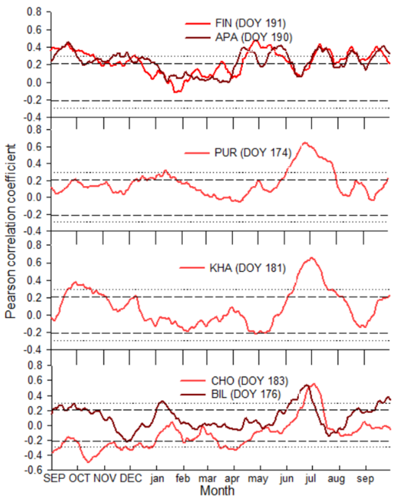 B 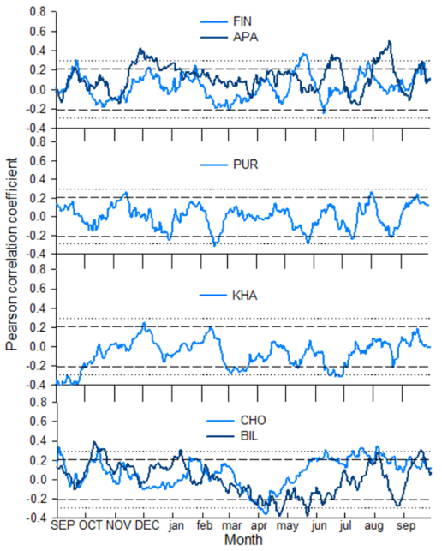

**Figure 3.** Sliding correlation coefficients (A and B) between standard tree-ring width indices and climate data (temperature and precipitation)

**3.2 Temporal stability of temperature signals**

Current correlations between standard chronologies show both positive and negative correlations with temperature for both individual months and aggregated temperatures of several months over the entire period. For the FIN and APA sites, there is no correlation with June temperatures over the entire period. Starting from 1976, the correlation shows the highest values, but also remains inconstant over time.

The central sites demonstrate stronger, and also constant over time, temperature responses for all considered months than in the other sites. Correlations for all months remain significant, but starting from the 1990s, the temperature signal gradually decreases.

For the CHO site, the temperature signal begins to decrease over time and around 1980 becomes insignificant for all considered months. On the contrary, for the Bilibino site, the correlations shifted over time to an increase in values ​​(around 1980), showing a higher response to all temperatures except July.

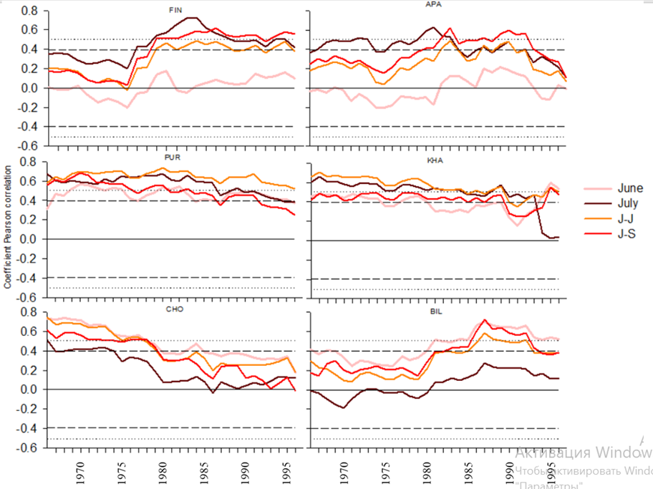

**Figure 4.** Sliding correlations (25-year window with 1-year step) of tree-ring widths with June, July, June-July, June-September temperatures for the total period 1966–2021

**3.3 Spatial stability of temperature signals**

Spatial correlation fields confirm the strong influence of June–July mean temperatures on PUR and KHA (r = 0.6 and 0.5 (P < 0.001), respectively). CHO show lower correlations for these months. Correlations of tree-ring width with June–September mean temperatures are high for FIN, APA, PUR, and KHA, reaching r = 0.3 for all sites except PUR (r = 0.4,) at P < 0.001 (Fig. 4A). Correlations with temperatures of the first two summer months are absent in June for FIN and APA and in July for BIL. June temperatures were moderately correlated with TRW for the CHO and BIL sites (r = 0.001, r = 0.001), respectively (Figure 4A), and July temperatures were moderately correlated with FIN and APA (r = 0.001, r = 0.001), respectively (Fig. 5).

|  |  |  |  |  |
| --- | --- | --- | --- | --- |
|  | JUN | JUL | JUN- JUL | JUN-SEP |
| FIN |  |  |  |  |
| APA |  |  |  |  |
| PUR |  |  |  |  |
| KHA |  |  |  |  |
| CHO |  |  |  |  |
| BIL |  |  |  |  |



**Figure 5.** Spatial field correlations between June, July, June–July and June–September mean temperatures (Berkeley 1°) and tree-ring widths for the period 1966–2001. Black dots indicate the locations of sampling sites.

???

Is it possible to add a description of the tree's characteristics here? Or should we remove this drawing as an addition?

Correlation analysis between standard chronologies showed significant values ​​for the FIN and APA regions (r = 0.46), where Pinus sylvestris grows, and for the CHO and BIL regions (r = 0.36), where Larix cajanderi grows. No significant values ​​were found for other regions (PUR, KHA), where the main species are Larix sibirica and Larix gmelinii.

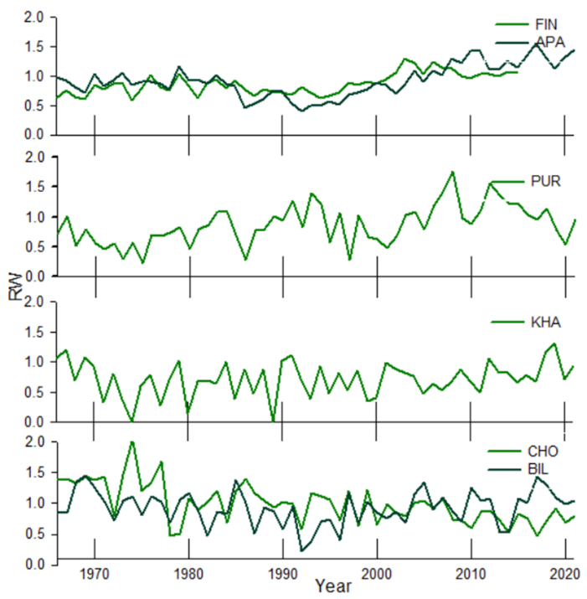 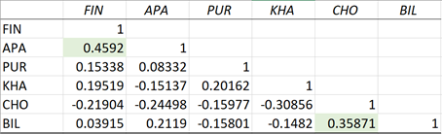

???

Can I take some average values ​​of the depth of the active soil layer?

Active soil layer and Snow depth

The Arctic Circle extends from Finland and the Kola Peninsula in the west to Chukotka and the Russian Far East in the east. It is a vast region with a strong influence of permafrost. However, the type and extent of permafrost vary depending on climate and geography, from isolated patches of frozen soil to widespread permafrost of 100 to 500 m. The depth of permafrost increases as you move east, causing significant changes in ecosystems. In the west, the soil freezes less and the vegetation includes mixed forests. While in the east, the climate becomes harsher and the soil freezes to a greater depth, limiting vegetation to tundra ecosystems.The depth of the active layer of the earth, as a rule, increases from west to east in the northern latitudes of Eurasia, which is associated with changes in climate and soil and plant conditions in this direction. In the west, the climate is milder and more humid, which limits the freezing of the ground. As you move east, the climate becomes more continental, with harsher winters. In Siberia and the Far East, winter lasts longer and is much colder, which contributes to deeper freezing of the ground and an increase in the active layer. Also, in the western regions, where snow falls gradually, the snow cover remains stable, creating a heat-insulating layer. In the east, in the continental climate of Siberia, snow falls in shorter periods and is sometimes less dense, which contributes to increased freezing of the ground, especially with strong winds that blow away the snow and reduce its insulating properties.

Soil types also vary by area. In regions with a milder climate, podzolic and peat soils predominate, which can support the growth of coniferous trees. In more eastern regions, permafrost, gley, and peat types predominate. The soils are poorer, which significantly reduces the ability of plants to grow.

Snow depth

Should we delete this drawing?

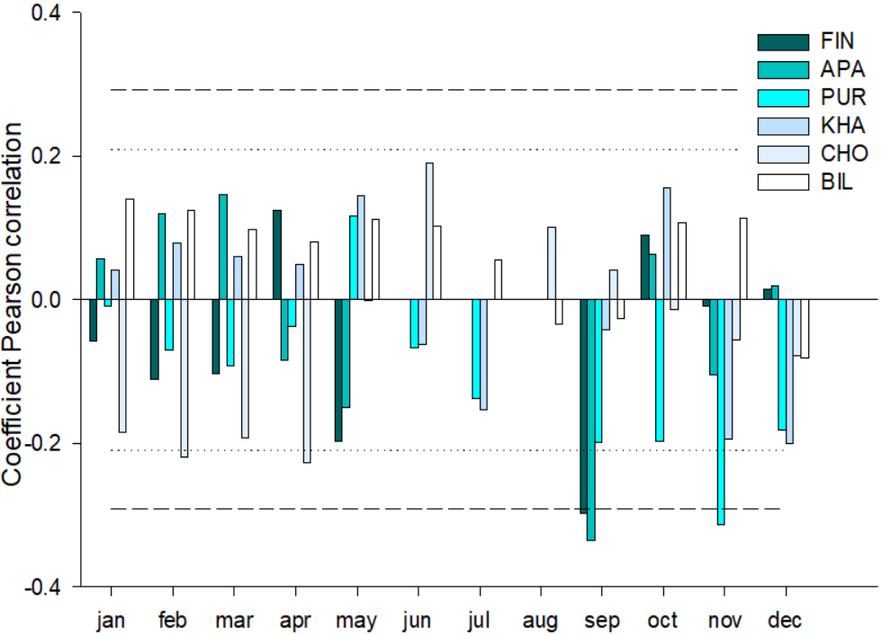

**Discussion**

The radial growth of trees in northern latitudes depends significantly on the temperature of the summer months (primarily June and July). This effect is expressed in regional features of the response of trees to climatic signals. The longitudinal gradient of the response to thermal conditions is manifested in the fact that in the central (PUR, KHA) and eastern regions (CHO, BIL) the temperatures of June are more significant, and in the western (FIN, APA) - July. The continentality of the climate increases from west to east: a decrease in the temperature of the coldest winter month, a decrease in the annual precipitation and snow cover thickness, as well as differences in the distribution of precipitation by seasons are observed (Borisov, 1967; Parmuzin, 1979). In the western regions, the maximum precipitation occurs in autumn, and in the eastern - in summer (July-August). However, even in summer, the monthly precipitation remains low (up to 40-50 mm), and the soils during this period experience significant drying out of the upper horizons. This leads to an early end of the radial growth of trees, long before the end of the calendar vegetation period (Vaganov, Shiyatov, Mazepa, 1966).

The duration of the warm period, as well as the beginning of the vegetation, differ by region. In the eastern regions of Siberia, the vegetation period begins earlier, since spring temperatures reach the threshold of +5 °C faster. This increases the contribution of June temperatures to the formation of annual tree growth (Vaganov, Shiyatov, Mazepa, 1966; Vaganov E.A., Hughes M.K., Kirdyanov A.V., Schweingruber F.H., Silkin P.P., 1999). In the western regions, the later start of the vegetation explains the dominant influence of July temperatures, coinciding with the peak of wood growth. Differences in the morphophysiology of Pinus sylvestris and various species of Larix sibirica, Larix gmelinii and Larix cajanderi also determine the response of trees to climatic factors (Pozdnyakov L.K., 1975). Pine, which has permanent needles, is able to maintain photosynthetic activity throughout the year, although its level is minimal in winter. This allows it to begin growing faster in the spring, using accumulated resources. Larch, which annually forms new needles, demonstrates a higher dependence on favorable conditions of the current season. This process requires significant energy costs, which can limit its growth in years with unfavorable conditions.

**Conclusion**

The main climatic factor determining the radial growth of trees in the studied areas are the temperatures of the summer months. For the eastern regions (for example, Chokurdakh, Bilibino), the most significant are the temperatures of June, while for the western regions (Finland, Apatity) - July. This difference is due to the continental climate gradient, which determines the timing of the beginning of the growing season and its duration.

Precipitation has a limited effect on wood growth, playing a local role only in certain months. For example, in the western areas, its value is higher due to more favorable soil conditions and a shallower permafrost depth, which improves the water supply of plants during the summer.

Pine and larch demonstrate different strategies for adapting to harsh conditions. Pine is able to start growing earlier by using last year's needles, while larch depends on the formation of new needles, which makes its growth more sensitive to seasonal climate changes. This difference highlights the importance of interspecific features in the adaptation of conifers to the extreme conditions of northern latitudes.

Supplements  
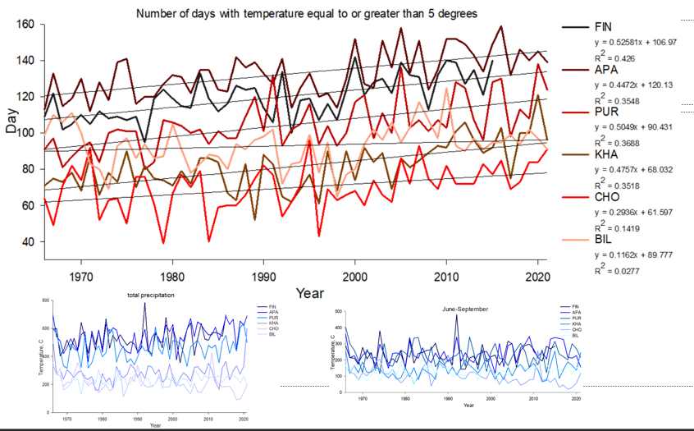

|  |  |  |  |  |  |  |
| --- | --- | --- | --- | --- | --- | --- |
|  | **FIN** | **APA** | **PUR** | **KHA** | **CHO** | **BIL** |
| Coordinates | 68°77′ N  27°15' E | 67°36' N  33°2' E | 66°54' N  65°45' E | 71°57' N  102°40' E | 70°30' N  147°10' E | 68°02′ N  166°40' E |
| Elevation (masl) | 179 | 127 | 125 | 35 | 7 | 468Начало формы |
| Near weatherstation | Sodankyla  (52 km) | Kandalaksha  (62 km) | Salekhard  (58 km) | Khatanga  (7 km) | Chokurdakh  (2 km) | Ostrovnoye  (48 km) |
| Number of trees | 35 | 18 | 26 | 18 | 20 | 20 |
| Average age of trees (years) | 162 ±59,4 | 263 ±73,6 | 133±35,9 | 300±36,7 | 331,35±118 | 163±22 |
| Mean dbh (cm) |  | 36.6 | 15.3 | 22.3 | 13.7 | 16.9 |
| Mean tree height (m) |  | 14.5 | 9 | 11.7 | 5.4 | 9.12 |
| Average tree ring width (mm) | 0,98+0,12 | 0,98+0,14 | 0,95+0,3 | 0,95+0,29 | 0,98+0,29 | 0,98+0,11 |
| Average number of days per year with temperature  ≥ 5 °C | 121+12,2 | 133+12,2 | 105+13,6 | 82+13,1 | 70+12,7 | 93+11,4 |
| Active soil layer deep (cm) | ? | ? | ? |  | 14 | ? |
| msx | 0.25 | 0.25 | 0.40 | 0.55 | 0.44 | 0.44 |
| EPS | 0.65 | 0.89 | 0.96 | 0.96 | 0.97 | 0.96 |
| Rbar | 0.48 | 0.40 | 0.63 | 0.68 | 0.64 | 0.69 |